Happy Christmas from us all at MeDiCT.
We have had a great year supporting disabled children in Mexico through the Instituto Nuevo Amanecer. They are spreading the knowledge we give them to many other institutes throughout the country ensuring that our influence and support has a greater and greater effect.
Some of the highlights.
1) My Visit to them at the beginning of the year when I was able to see amazing progress.
It felt like all the work over the last 16 years had suddenly accelerated, with wonderful results for so many children.
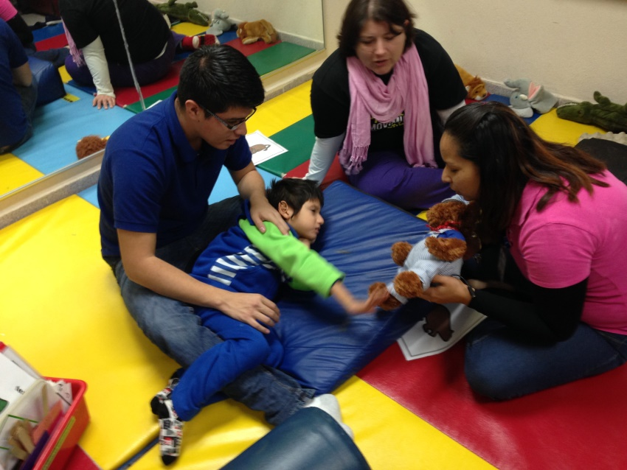
This shows how all the different disciplines are working together, to the same goals, sharing skills and giving the child a much better chance of making progress.

2) Visit of the British Ambassador to Mexico and British Consul from the State of Nuevo León to see the work which MeDiCT does to help disabled children in Mexico.
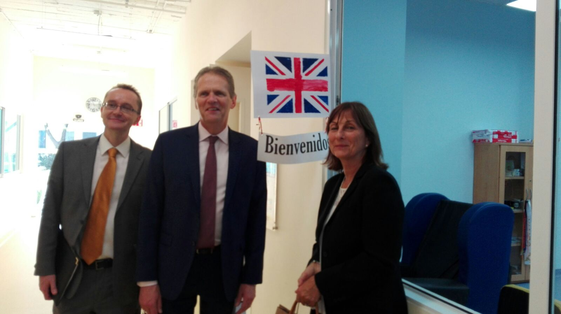

3) Visit of Armando Gillando to UK to visit SOS and Treloar School. Armando is the manager of the CAP which is the postural management clinic. An excellent opportunity for Armando to learn many new things and make excellent contacts.

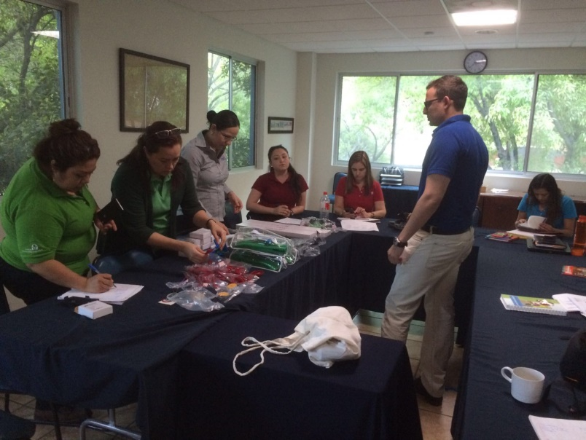
Armando on his return to the INA relating back on all he had seen and learned.
4) Sending of the latest container which will help so many poor families to have the equipment they so desperately need to help their child to have a more independent life.

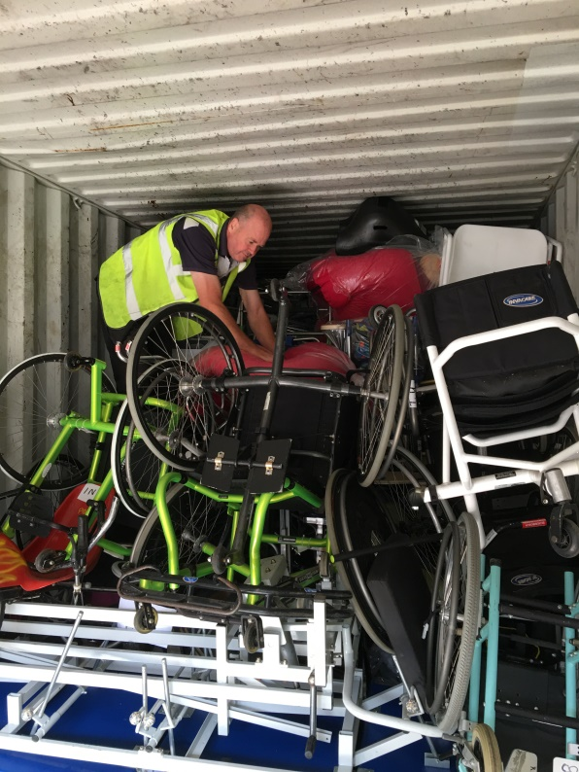

5) Chailey Postural Management Training Course

This was a hugely successful training which I had offered to do as a distance learning training for one physiotherapist. It ended up being for all the therapists as well as all the teaching staff and it proved to be an excellent learning experience which can be used again and again.

.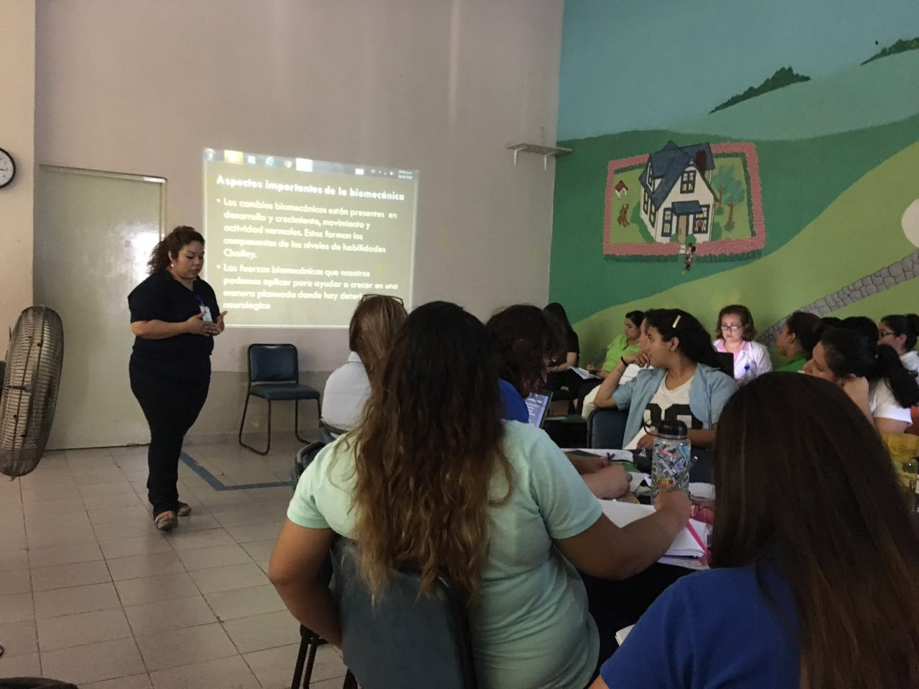
Different members of staff were involved and took on the responsibility of presenting different sections of the training. The feedback from everyone has been extremely positive. This is Fabi, the Head Occupational Therapist who has recently finished the distance learning Occupational Therapy degree course, sponsored by MeDiCT.

6) Visit of three INA staff to UK, two of them also visiting Holland. MariCarmen head of the school in the INA, one of the teaching staff, Caty, and Armando. All three had an excellent well planned week at Treloar and then MariCarmen and Caty went to Blixembosch in Holland whilst Armando remained in England for the second week. All three learned an incredible amount from the two weeks in Europe.

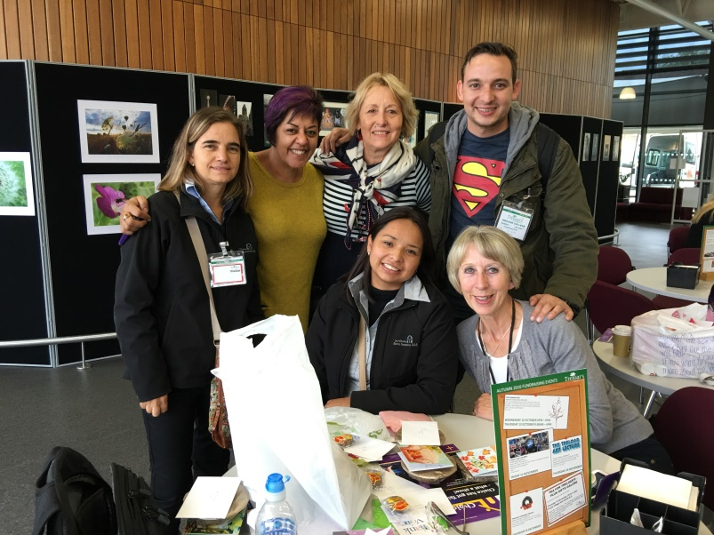
Back row. MariCarmen, Pretty, Sarah, Armando, Front row Caty and Flossie. Flossie and Pretty from Treloar have both visited the INA and provided excellent training, both have committed to go again to do more training.

7) Donations of equipment.

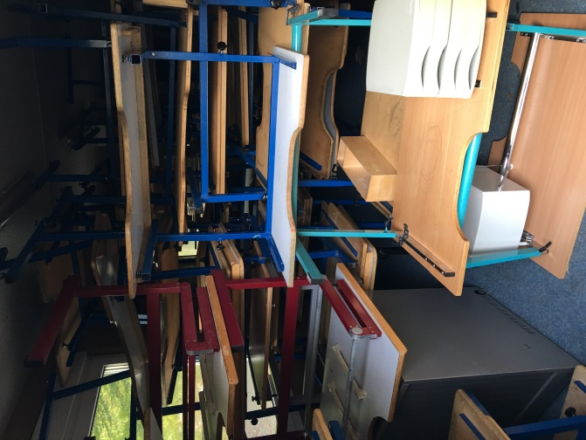

Excellent equipment in the form of adjustable classroom furniture which is being replaced in Blixembosch in Holland and will be donated to the INA.

We have also received some excellent donations from another charity PHYSIONET.

8) Visit of Cristina Bolanos to INA.
Cristina Bolanos is the Director of the Occupational Therapy degree course in the university in Mexico City. This is her first visit to the INA. She was able to see her two now qualified students Paulina and Fabi at work in the INA. Paulina and Fabi worked as OT's in the INA for many years, with their very basic training but also with a huge amount of extra training from MeDiCT, both have visited the UK for training and finally both have completed the online degree course sponsored by MeDiCT over the last three years. Cristina was overwhelmed by the very high standards of treatment she saw in the INA not only by Paulina and Fabi, but she commented on the excellence of the INA as a whole. The University in Mexico City is to extend the training programme to be available in Monterrey and the INA will become a clinical training centre. This is wonderful news as more rigorous training for therapists is very much needed.

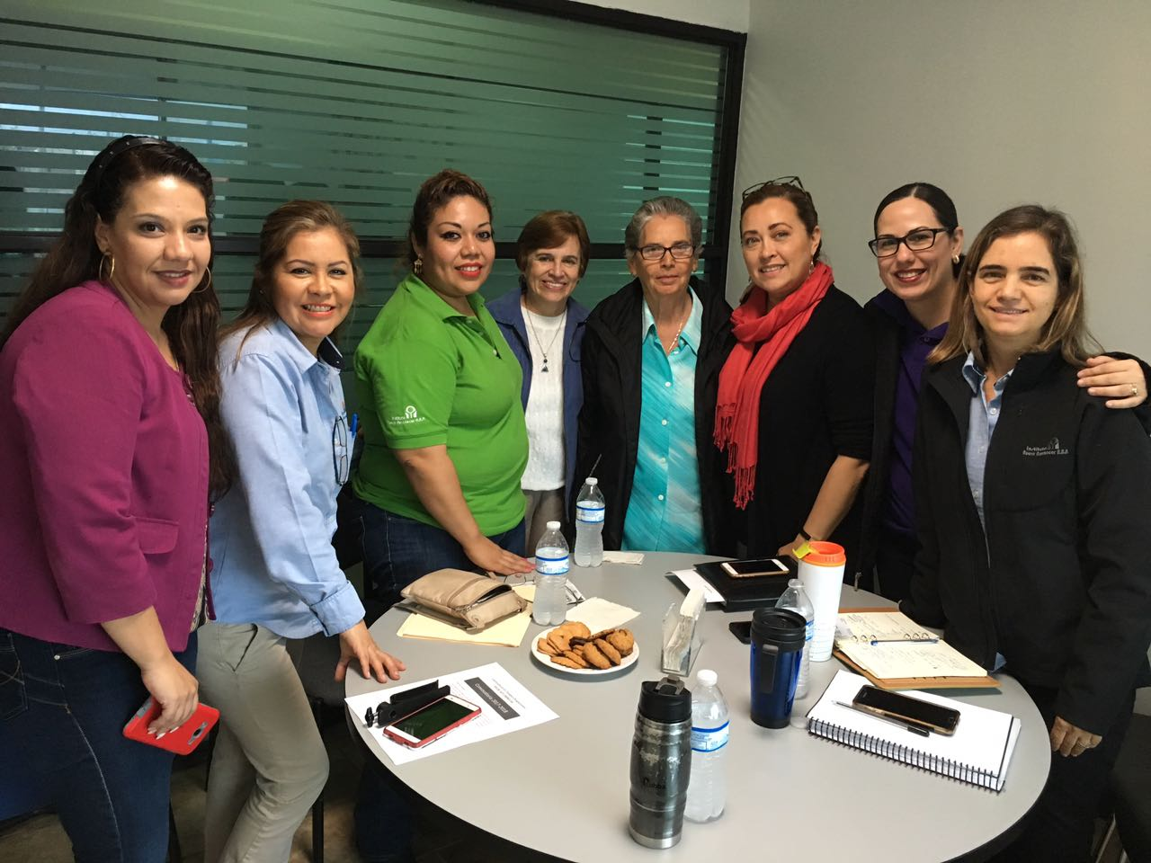

Cristina Bolaños and her colleague (centre) with members of the management team from the INA and Paulina and Fabi, her prize students 2nd and 3rd from the left.

9) APT training course. Appropriate Paper Technology.
Training course for making low cost vital equipment for very poor communities.
As most of our supporters know the INA is now a centre of excellence for children with Cerebral Palsy, and able to provide the equipment which these children need to help them to become as independent as possible. This equipment is also vital to prevent children from developing debilitating and painful deformities. Sadly parents have to pay for this equipment and whilst the INA try hard to help them, some may never manage to get the money together. The training which MeDiCT found and funded for the INA shows very poor communities how to make this vital equipment from waste products, mainly corrugated cardboard and carton. The equipment is strong and durable and only costs time to make. Six Mexican centres attended this training, the idea being that therapists learn how to assess the child and parents attend as well. They all learn how to actually make the equipment but on returning to their own clinics, the therapists assess the child and prescribe the appropriate equipment, the parents actually make the equipment and teach other parents how to do this too. The whole idea is to make this sustainable and an ongoing resource helping very poor communities of which there are very very many.
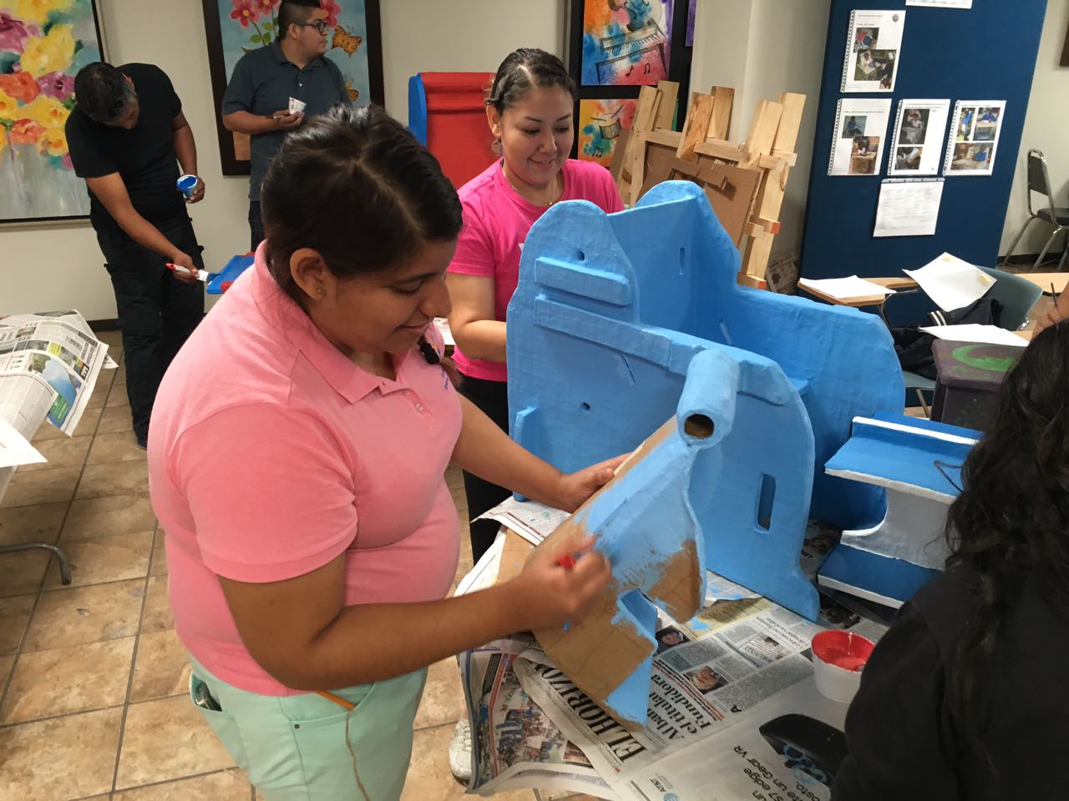
This shows a seat which has been made for a child and has a special insert to help with the postural management of the child

10) Visit of two highly specialised therapists from Blixembosch in Holland.

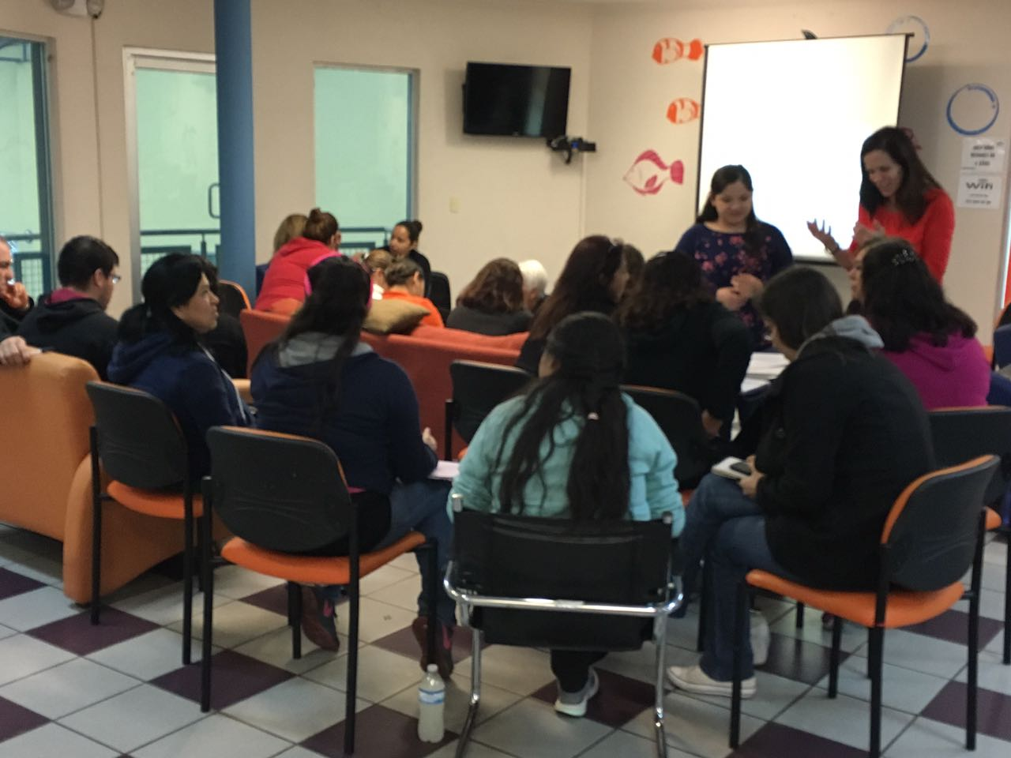

Ans is a Speech and Language therapists and her training is very much needed in the INA. Children with CP are very much at risk of choking or developing lung infections because of the difficulty they have swallowing. This can be very serious and sometimes even life threatening. Ans has spent her whole career in this field and her input in the INA is very much needed as this is a speciality with very few experts (if any) in Mexico.
Greet is a physiotherapist who is highly experienced in treating children with multiple problems, including learning disability. These children are difficult to treat in any part of the world but for therapists who have less training than we do in our countries here in Europe they can present many problems. As I write this Greet and Ans are in their second week working hard to support training in the INA. Greet is also an expert in foot orthoses and will attend clinics to give support in this field. She is also involved in something called "Go Baby Go", where toy cars are adapted at low cost, to give very young children the experience of moving themselves. This is a vital part of development for the young child and already there are a couple of these small vehicles adapted for the tiny children.

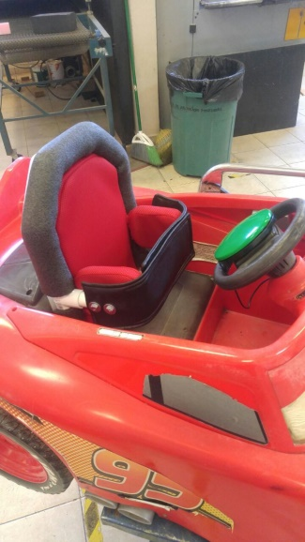

11) This container arrived in July, having been sent in January 2016
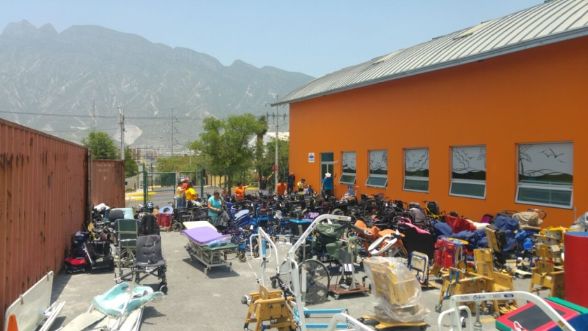

The container below arrived in December and is ready to be unpacked.
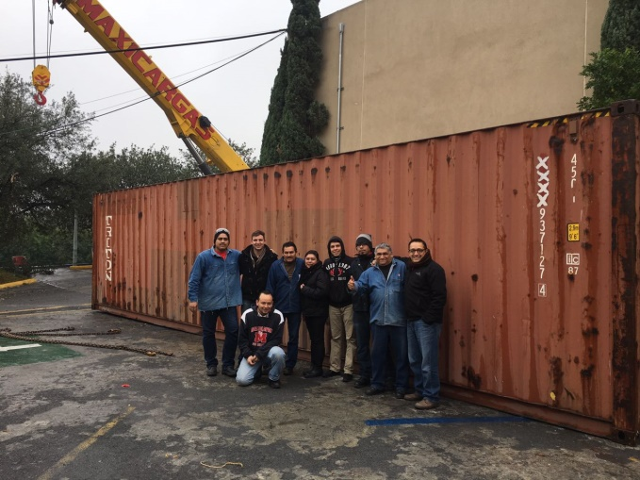

Finally I would like to thank you all for the tremendous support and encouragement which you have given us through all these years of hard work, striving to make a sustainable difference to the treatment and education of disabled children in Mexico.

Sarah. December 2016

